……….
30723 Sodaville Rd Lebanon, Oregon
December 2020 Volume 12 Issue 20

City Hall (541) 258-8882 Mayor Suzie Hibbert email: sodaville@cityofsodaville.org
Web Address: www.sodaville.org Judy Smith – City Administrator
000000000000…………..000000000000000000000000000000

City Council Meeting City Hall Hours
7:00 pm December 17, 2020 Mon. – Thurs. 10 am – 2 pm
CITY UPDATE
I will be leaving my position as City Administrator for the City of Sodaville in a couple of months. I have been diagnosed with end stage liver disease (non-alcoholic, I didn't even have fun earning it). The Council met on December 1, 2020 at 7:00 pm at City Hall and discussed finding someone to replace me. Salary, benefits, etc. The posting for the City Administrator position will be found on the website www.sodaville.org in the near future. If you know anyone that may be interested in the position which for the most part requires a strong finance background, and being familiar with Government Accounting and laws, let me know. I will train someone in all the other aspects of the job. A full job description will be posted soon.
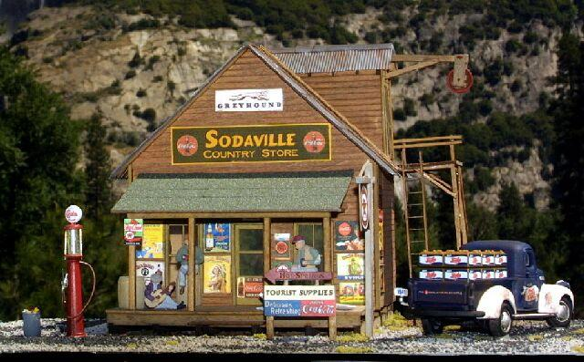
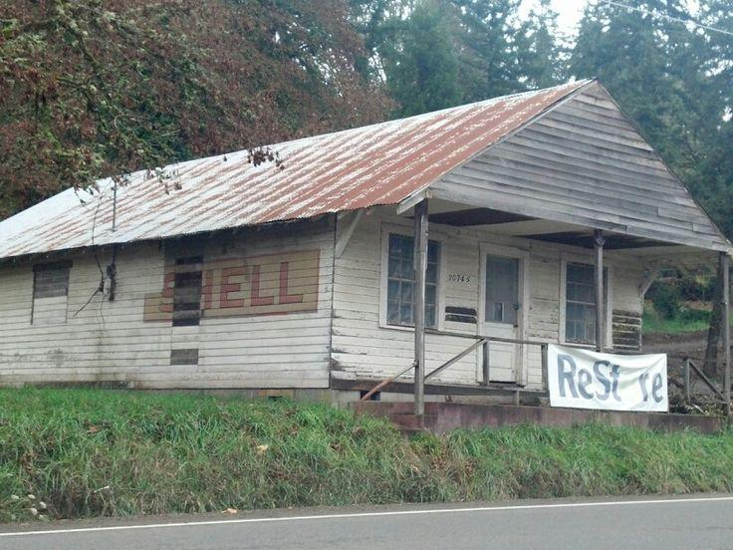
Sodaville History – Old Store by Maxine Dargis
“In 1930, this small building, which was located north of the present old Store building, housed a small store and post office. In those days, every one within Sodaville had to pick up their mail here at this post office. Needless to say, this was a very busy spot. About 10 AM every morning, if there was no mail for people, at least they could catch up on local gossip.”
“The old vacated Sodaville store still stands on this location. It was built by the Satterlees, then owner of a small store to the north. In 1930, the site was just a pile of rubble left after the 1929 fire destroyed Hill's Hall (the old store building). Before it burned, Hill's Hall was a large, two-story building built by the Sodaville band in the late 1890's. The fire started about mid-morning on a week day. Many, many local residents came quickly to help. They carried out as much merchandise as they could before the building collapsed. I remember this fire very well. It was a huge fire and a hot one that raged out of control. It was an all wood building and the floor in the store had been heavily oiled to control the dust. How the church bell clanged. It was a custom to ring the local church bell when there was a fire in Sodaville. Quite often an eager or excited bell ringer would pull too hard and tip over the bell. Then someone would have to climb up in the belfry to tip it back. In my memories I can still see the inside of this old store. It served the whole community and stocked just about anything you would need. Shoes hung from rafters, overalls, shirts and other clothing on one side, and groceries on the other. Even had a section of harnesses. I can also remember the smell of the pickle barrel.”
Merry Christmas and a very Happy New Year!! Judy Smith, City Administrator (cell: 541-905-2590)
MAYOR’S MESSAGE
Merry Christmas Sodaville! It’s December 2020 and time to celebrate the true meaning of Christmas. It’s been a rough year for everyone and we are discouraged and frustrated. But looking at the twinkling Christmas lights and listening to the cheerful music, having my sweet littlest granddaughter beside me, life isn’t all bad. So, to look for the blessings. We have all been blessed many times over throughout the year. One blessing is that we have had more rain this Fall and are almost done water restrictions! We are just waiting to have all 5 wells back on track and running full. We started a month later, and due to it not being so very dry, we did not have to truck in so much water, thus saving the City money. Another blessing!
Let’s do something different this year. Please add something you've been blessed with to your water payment and in January we’ll put them in the newsletter. I can’t wait to read yours! January is my last newsletter to you, with the Mayor and Council member changes. I do believe Lori McAllen and Adina Olivaries will be good for the City. Along with council changes, Stan and Judy are both retiring soon, there will be many sad and sometimes frustrating moments to all. Speaking of the Administration changes, we are looking to replace the (almost) irreplaceable. If you know of someone interested send them to our website Sodaville.org As 2020 winds down as a rough year, 2021 shall be trying also, but Sodaville is strong and many know of Sodaville as stubborn, we shall push through and end 2021 blessed also.
Merry Christmas Sodaville! And Cheers to a New Year!! Mayor Suzie Hibbert

Public Works Newsletter
After some significant rainfall the City's wells are starting to produce more water. The City's reservoir has been filling on its own for a couple of weeks now (although slowly) and two of the City's five wells are showing improved water production. The current water restriction will remain in effect until all wells are producing normally and the City's reservoir is full.
We finally got the upright post in on the City's Sport Court. I will be working on the rest of the framework necessary to install the fencing for the next couple of weeks. Once ready the City will be looking for volunteers to help install the fencing. The fencing is heavy and will probably have to be shortened into section to be installed. If you would like to be involved in the installation please give me a call at 541-401-8537. I will be happy to have your help.
I hope you all have a Merry Christmas and a Happy New Year! Stan Smith, Public Works Director
Country Girl Quilting
*Long-arm Machine Quilting
Call Sharon Hill and Joleana Altom at 541-401-7936
Carrie’s Country Inn Adult Foster Home
is located at 30785 Washington Street in Sodaville. “A safe, comfortable home
where you can keep your dignity, respect and independence.”
For information call: 541-570-1430
If you have any announcements, information or ads you wish to have published in the newsletter,
please call before the 6th of the month and I will be happy to insert them!
“The City of Sodaville is an equal opportunity provider and employer.”

