……….
30723 Sodaville Rd Lebanon, Oregon
July 2019 Volume 7, Issue 19

City Hall (541) 258-8882 Mayor Suzie Hibbert email: sodaville@cityofsodaville.org
Web Address: www.sodaville.org Judy Smith – City Administrator
000000000000…………..000000000000000000000000000000

City Council Meeting City Hall Hours
7:00 pm July 18, 2019 Mon. – Thurs. 10 am – 2 pm

CITY UPDATE
A lot of progress is being made on the Soda Springs Community Center Park thanks to the volunteers that have worked many Saturdays and Sundays. Work will continue starting July 13 & 14, from 8:30 to 4:00. Please help!

City Council passed the 2019-2020 Fiscal Year Budget. You can find it online at www.sodaville.org. Two Public Hearings will take place at the July 18th Council meeting, a Setback Variance application and an Accessory Building Variance application. The new Franchise Fee Agreement with Comcast will be discussed. The full tentative Agenda is online. The new time for the Citizen Planning Committee meeting is 6:15 pm on July 18. Please join them and share ideas of what projects or improvements you would like to see in the City.

The City Council passed the amendment to the City Building and Zoning Code that allows for Accessory Dwelling Units to be built. The rules include 1 unit per lot, not to exceed 700 square feet or 75% of primary home. For more information, please contact City Hall. This will allow for small homes for elderly relatives, college students, etc.

Sodaville History:
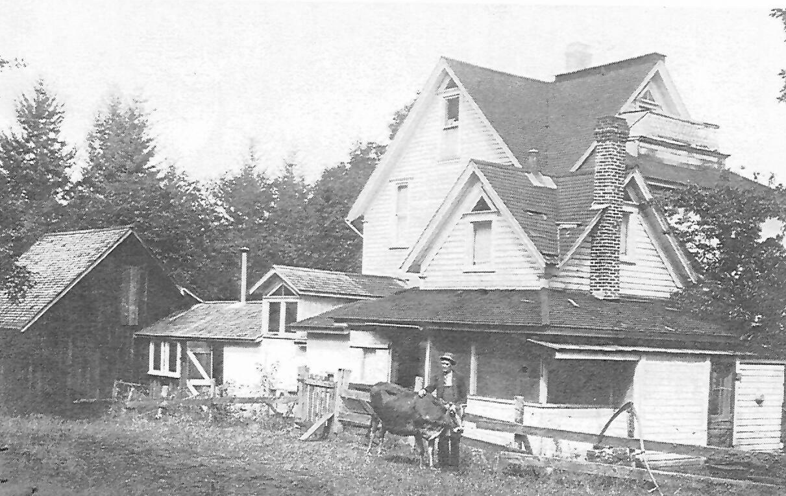
One of the most interesting bits of history that is recorded in the story of Sodaville is the one about Andrew Hale. This is a story of a house that was never finished by the spritualist who built it. The original structure show evidence of a definite plan, but from there on the spirits seem to have taken over. For 17 years he continued to make additions and changes. Whenever the spirits moved him, he built an addition enclosed a porch, changed a partition or whatever the spirits instructed. A neighbor once asked him why he used such enormouse posts in the under pinning of his house, He replied “You would be surprised how much weight this house holds up at night.” (How heavy is a spirit?) Along with the strange rooms and additions there were 5 doors that opened into a blank wall. Finally, the spirits in his imagination at night became more than Andrew Hale could take. He quietly hanged himself in an oak grove near his home. The house now back to its original structure is located in western Sodaville.
Judy Smith, City Administrator
MAYOR’S MESSAGE
July seemed to show up very quickly! The Park is coming along, what do you think? It’s looking so nice! The playground is coming right along, but is not ready yet. So please be sure your children understand that it is not ready. Safety First!
The Citizens Planning Committee is coming up with ideas of how to landscape the Park. Do you have any ideas you would like to share? Come join us on July18, 6:15pm. We were talking about doing some sort of a memorial garden, families could sponsor their loved ones who have lived in Sodaville, with a plant/rose, a brick in a path, or a bench or picnic table. Just thoughts floating around, do you have a preference? Or another thought? We do have plenty to do, so please come help us finish it up so we may be able to enjoy the park as soon as possible.

Please continue to be aware of your water use. We have a well offline, and another well with reduced water flow. Yes, we are still working with getting the new well to happen. We are dealing with a lot of red tape.

Take care and see you around!

Suzie mayorhibbert@gmail.com

Public Works Newsletter
Summer is finally here and it seems to be taking a toll on the City's water system. Many of you know that with the coming of the summer months, comes the water restrictions. The City is not at that point yet but if high consumption continues by many of the City's residents, water restrictions will have to be set in place. I would like to ask the citizens of Sodaville to start voluntarily restricting their water use as of today. Use water when you have to but don't overuse it. Take your car to the car wash instead of washing it at home. Don't water your lawns but do water your gardens. Please turn your hose bibs off when not in use, leaving them on leads to leaks and high water bills. Trucking water in from Lebanon is very expensive. The City not only has the cost of the water but the cost of hauling it here. Let’s work at keeping the City's costs down so that those extra costs are not reflected on your bill.

Everyone should have received a copy of the 2018 Consumer Confidence Report. If for some reason you did not receive one and would like one, copies are available at City Hall or on the City's website at www.sodaville.org. Hopefully, next year we will deliver the CCR's in electronic form with paper copies available to those who wish one.

Stan Smith, Public Works Director

Country Girl Quilting
*Long-arm Machine Quilting
Call Sharon Hill and Joleana Altom at 541-401-7936

Carries Country Inn Adult Foster Home
is located at 30785 Washington Street in Sodaville. “A safe, comfortable home
where you can keep your dignity, respect and independence.”
For information call: 541-570-1430

If you have any announcements, information or ads you wish to have published in the newsletter,
please call before the 6th of the month and I will be happy to insert them!

“The City of Sodaville is an equal opportunity provider and employer.”

