……….
30723 Sodaville Rd Lebanon, Oregon
February 2019 Volume 2, Issue 19

City Hall (541) 258-8882 Mayor Suzie Hibbert email: sodaville@cityofsodaville.org
Web Address: www.sodaville.org Judy Smith – City Administrator
000000000000…………..000000000000000000000000000000

City Council Meeting City Hall Hours
7:00 pm February 21, 2019 Mon.–Thurs. 10 am–2 pm
CITY UPDATE

city hall and public works will be closed FEBRUARY 18
Work has begun on the Soda Springs Community Center Park. Big Valley Builders, Inc. from the City of Brownsville began by inspecting the existing septic system, which of course was not in good repair. Once the septic is repaired or replaced, the new 2 bay restroom with running water and electricity can be placed. Following will be the new parking areas, driveways and sidewalks. The contractor is hoping to have the full project including the new children’s play area, a barbeque patio and the horseshoe pits done in the next few months. The City will need many, many volunteers to help build the playground and horseshoe pits along with landscaping. Please contact City Hall if you are interested in volunteering time, money or equipment to help!
Here is more City of Sodaville history:
Mineral Springs College, which played such an important part in the history of Sodaville, started as a seminary founded by Louis Barzee and his brother Charlie. The former first came to Sodaville as a teacher in the public school, and decided that the place was ideal for a seminary because of its reputation as a resort, the beauty of the surroundings and the fact that land could be secured by donation. Mineral Springs Seminary, later Mineral Springs College, was founded in 1892 and operated with 100 students through 1910. The current Crowfoot Grange was once the college dormitory. It is said that the dormitory was moved by rolling it on logs from the City of Sodaville until it reached the destination in Crowfoot.
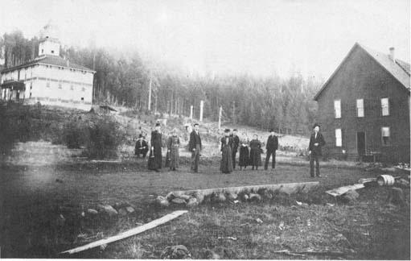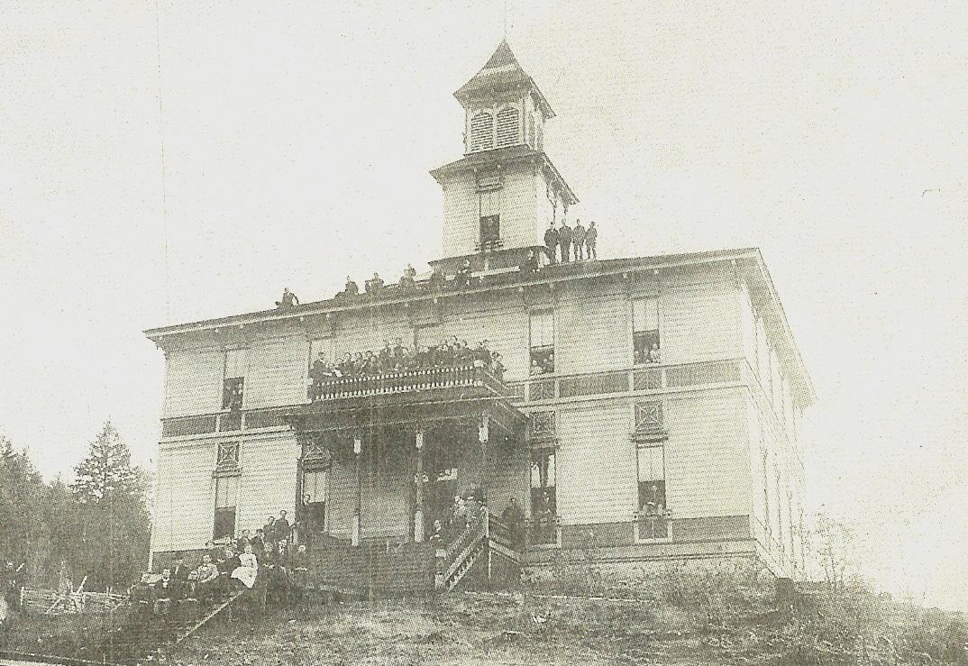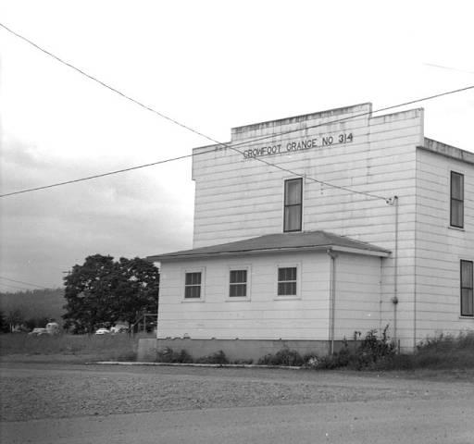
Judy Smith, City Administrator
MAYOR’S MESSAGE
Wow, February already!

Enjoying the snow? Be prepared. Also, if we do actually get several days of cold, icy weather, look to see if your elderly neighbor could use anything from the store. Or wood brought in, even just getting the mail for them. Pay it forward.

Citizens Planning Committee Meeting will be held at 6:30 rather than 6. There isn't much going on that's needed to be planned. We do need the pipes cleaned, possibly primed and painted for the sport court fence. This could be done most anytime. Just contact Stan or me. They have all been cut, and many have been primed. Stan and I, (mostly Stan) have been picking away at it. We too, have plenty of other things to do, which keeps the project dragging on....ugh
We do hope to start making plans for float for the Strawberry parade. It was disappointing last year when it all fell apart. And yes, I do take part of the blame on that. This year, let's do this! We need your help, please get involved.
We are gearing up for the Budget meetings again. And if you have something you'd like to toss out there as an idea for the City to possibly fit into the budget, bring it to the Council. And think about being on the Budget Committee, it would be awesome to have you. We always need more people.

I never mention my family's business, but since I just got a new grandson, I thought I'd announce him. He is #6! I now have 1 granddaughter and 5 grandsons!

As always, take care and see you around!

Suzie mayorhibbert@gmail.com

Public Works Newsletter
As you all know the City's water restriction was lifted as of January 1 this year. As I am writing this there is snow on the ground in Sodaville which to some of you may indicate plenty of water. The truth is so far this year the region has not seen normal or adequate rainfall. I am hopeful that will change and we experience heavier than normal rainfall this spring. The City's wells depend on rainfall to replenish their aquifers. Please continue to conserve water this year so we don't get into the same situation of water restrictions this coming summer.

Here's a cold-weather checklist to keep your pipes from freezing this winter:
- Disconnect outside water hoses. If left connected during freezing temperatures, water in hoses will freeze and expand causing connected faucets and pipes to freeze and break.
- Inspect outside faucets. If dripping or leaking, make the necessary repairs or call a plumber before a hard freeze.
- Cover outside faucets using a faucet insulation kit.
- Note that when pipes freeze, water pressure builds causing cracks, no matter if the pipe is made of plastic, copper or steel. Even a tiny crack can unleash 250 gallons of flood-water in a single day.
- If your home is equipped with interior shut-off valves leading to outside faucets, close them and drain water from lines.
- Insulate pipes in unheated areas. It's a lot easier to do this on a pleasant day than when cold winds are blowing. Apply heat tape or thermostat-controlled heat cables around exposed pipes.
- Make sure the furnace is set no lower than 60 degrees during the winter to prevent pipes from freezing.
- Close vents in foundation and attic to keep cold air out.
- Open cabinet doors under sinks on exterior walls to allow warm air in.

Stan Smith, Public Works Director
Country Girl Quilting
*Long-arm Machine Quilting
Call Sharon Hill and Joleana Altom at 541-401-7936
Carries Country Inn Adult Foster Home
is located at 30785 Washington Street in Sodaville.
“A safe, comfortable home where you can keep yourdignity, respect and independence.”
For information call: 541-570-1430
If you have any announcements, information or ads you wish to have published in the newsletter, please call before the 6th of the month and I will be happy to insert them! “The City of Sodaville is an equal opportunity provider and employer.”

