……….
30723 Sodaville Rd Lebanon, Oregon
September 2018 Volume 9, Issue 18

City Hall (541) 258-8882 Mayor Suzie Hibbert email: sodaville@cityofsodaville.org
Web Address: www.sodaville.org Judy Smith – City Administrator
000000000000…………..000000000000000000000000000000

City Council Meeting City Hall Hours
7:00 pm September 20, 2018 Mon.–Thurs. 10 am–2 pm
CITY UPDATE
Water Conservation
It is the time of year when the dry, hot weather starts to affect the wells. Please try to conserve water when possible.
The reservoir is dropping as all 5 well levels lower. There currently is no mandatory water restriction but if voluntary conservation does not happen, restrictions can be put in place. This could result in fines for extreme water users. Please limit car washing, lawn watering, and unnecessary use of water. CONSERVE Once the 6th well is operational, the water system should have the capacity so that future use will not be as affected by the hot summer months.

I have received the final documents for the 2018 Election. Mayor Suzie Hibbert and Council President Roger Perry are seeking reelection on the November 6, 2018 General Election Day. Councilor Ray Jackman has not submitted his name for the ballot but has chosen to leave it up to the voters to reelect him with write-in votes once again.

Judy Smith, City Administrator
MAYOR’S MESSAGE
September, I love the smell of Fall, the crunch of dry leaves and the kids going back to school. Remember to watch for the kids walking along the road and waiting for the buses. That said, SLOW Down and be aware of things around you.

We now have the money for the Water Project to start truly getting underway. Which is very exciting, it’s amazing how long everything takes.

The Parks Grant is still waiting for contractors to come do the job. Know anyone, send them our way! There is a time limit to get this completed.

I wanted to remind everyone that the City does have Rules, Regulations, Codes and Ordinances. It is your job to educate yourself of them, just be aware that there may be something you should check before you get started on a project. The website, Sodaville.org has the most requested codes.

You are all invited to come join in the Citizen’s Planning Committee, Thursday @ 6 pm 9/20/18, followed by Council Meeting @ 7 pm

See you around,
Suzie
mayorhibbert@gmail.com

Public Works Newsletter
It's been a long hot summer and that has taken its toll on the City's water system. The City's reservoir is currently down a couple of feet due in large part by high usage and a higher than normal amount of leaks. Leaks happen and we can't control that but we as residents can control the high usage. Please only use water as needed and we will get through this without having to purchase water from Lebanon. I don't think anyone here likes Lebanon water and what it does to the City's pipes ends up at your tap in the form of dirty water. Currently the City of Sodaville is holding off on “Water Restrictions” in favor of voluntarily cutting usage. If water restrictions become necessary at a later date they will be enforced. That means no watering lawns or washing cars inside of the City Limits. If caught watering or washing a vehicle a fine may be imposed. I for one don't want to do that. Let’s all conserve and get through the summer with what we have.

Recently a cross-connection was found between a well and City water supply. The City of Sodaville along with the State of Oregon and Federally the EPA all have regulations against cross-connections. The City of Sodaville has always had a cross connection ordinance but in 2017 those regulations in the form of a revised “cross-connection ordinance” was passed by the City Council and became law in Sodaville. If you own a well and it is connected in any way to the City's water supply without additional protection you are in violation of that ordinance. Use of a well connected to a City water supply requires additional protection in the form of an RP Device (Reduced Pressure Principle Devise). If you use an underground sprinkler system connected to the City water supply you must have a double check valve. Both of these devices prevent back flow into the City's water system. Both of these devises require testing by a State Certified Cross-Connection Specialist once a year or any time maintenance is performed and repairs made to the devises. Results of those tests must be mailed to the City of Sodaville before March 1, of every year. There is a fee associated with the testing. A single check valve is not testable and not sufficient!!

As a result of the illegal connection that was found I will be conducting an audit of all wells in the City for cross-connections. If illegal connections are found the City will shut your water off and a fine of $500.00 will be imposed. Your water will not be turned back on until the cross connection has been removed and the fine has been paid. The audit will begin shortly and each property owner with a well will be contacted and a time will be set for the audit.
The City of Sodaville tests the water it delivers to your tap every month. Well water on the other hand is not tested and in fact is why the City has a water system. Many years ago before the water system was put in people started getting sick from their well water. Why? Because the water was not tested and sewer from their septic system made its way into the wells. This is the reason for cross connection regulations. An illegal connection to a well puts everyone on the water system at risk not just the well owner.

Stan Smith, Public Works Director
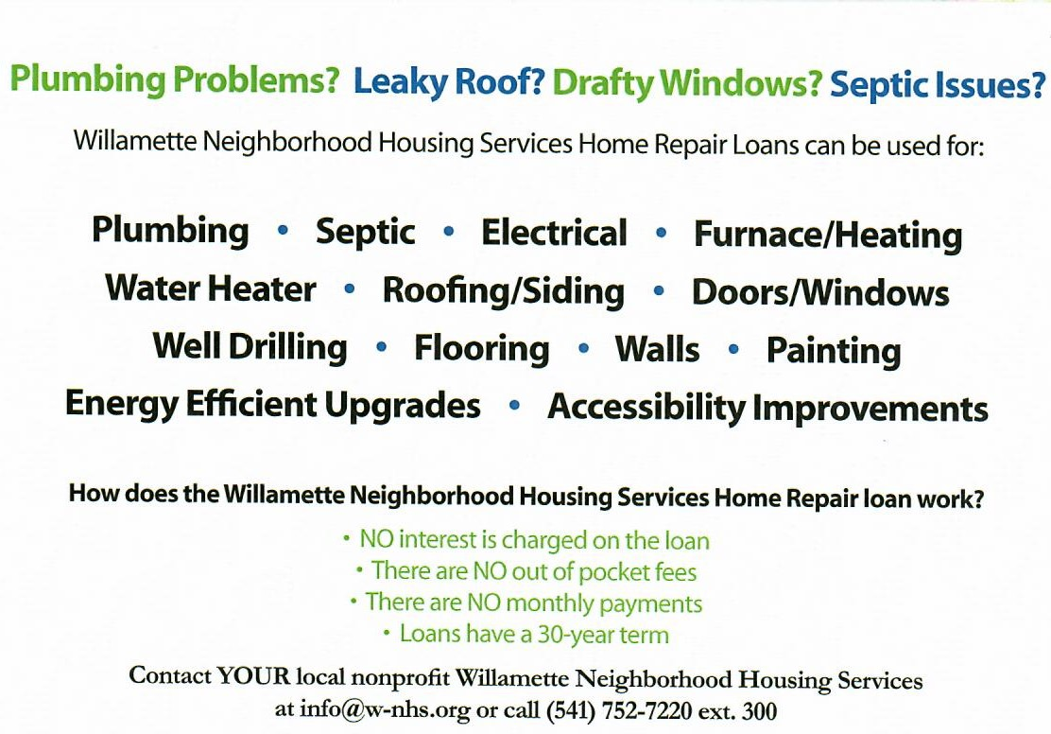
Country Girl Quilting
*Long-arm Machine Quilting
Call Sharon Hill and Joleana Altom at 541-401-7936
Carries Country Inn Adult Foster Home
is located at 30785 Washington Street in Sodaville.
“A safe, comfortable home where you can keep your
dignity, respect and independence.”
For information call: 541-570-1430

If you have any announcements, information or ads you wish to have published in the newsletter, please call before the 6th of the month and I will be happy to insert them!
“The City of Sodaville is an equal opportunity provider and employer.”

